Root and Branch Inclusive Synod, 5-12 September 2021 (Zoom/Live)

Inspired by Pope Francis’s synodal vision, lay Catholics from across the UK invite you to embrace and advance renewal, reform and healing in the Catholic Church.

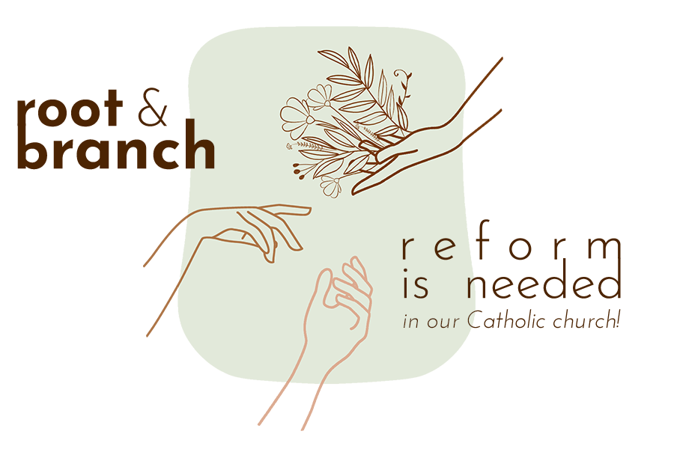
Already zooming twice-monthly, Root and Branch Inclusive Lay-led Synod reaches its conclusions with panels of theologians and thinkers presenting their findings each evening on Zoom from Sun 5 – Wed 8 September.

The Synod culminates in a conference of international speakers from noon Sat 10 September to noon Sun 12 September 2021 in Bristol and on Zoom. It opens with a welcome from Bishop Declan Lang. Professor Mary McAleese, canon lawyer and former President of Ireland, is the key-note speaker.

Tickets for Zoom and Live participation are now available at www.rootandbranchsynod.org

www.rootandbranchsynod.org
hello@rootandbranchsynod.org
+44 7968 390420

