Dear

Root & Branch Inclusive Synod - Unfettered Discussion on ALL Topics on Equal Terms.
Be Heard.

You may not be aware of an organisation called Root & Branch, a voice for committed Catholics who desire fundamental change in the Catholic Church. Our website can be found at www.rootandbranchsynod.org. It includes information about the movement’s ethos and hopes, presentations from diverse speakers on the future of the Catholic Church and about the upcoming inclusive Synod to which all are welcome.
This inclusive lay-led Synod, organised by Root & Branch, will take place on Zoom and in person in Bristol in September 2021. The Synod is special because ALL topics of concern to ordinary Catholics will be open for discussion in the hope that a consensus will emerge and be recorded in what will be called The Bristol Text. It is hoped that this Text will become a key reference document which will support and encourage all Catholics participating in the Diocesan phase of Pope Francis’s Synod on Synodality which starts in October 2021.

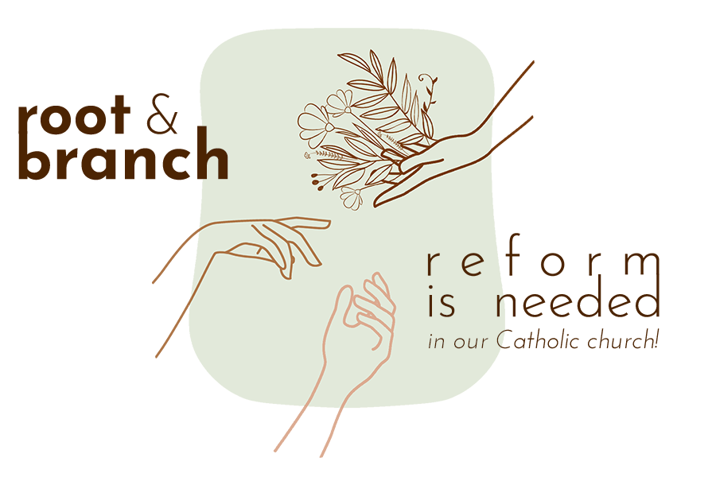
Following discussions and discernment, The Bristol Text will set out proposals on the far-reaching topics of:
1 Redefining and reclaiming of ministry
2 Embracing diversity
3 Rethinking moral theology
4 Insisting on sharing authority
Tickets for the Synod are now on sale on the website. They start at £10. Change will only happen if there’s grass roots support for it so do buy a ticket. If you are unable to participate in the final exciting week of the synod 5-12 September (all of which is available on Zoom), it would be wonderful if you were to join Root & Branch by signing up for free on the website. This would give you a voice in ongoing discernment and provide access to future speakers on Zoom.
I am sending you this message because I feel called to participate in the task of publicising Root & Branch as a beacon of light. It gives me hope for the future of the Church which has given so much to me, yet for whose future I have great fears. If you share this calling, please feel free to forward this message to other Catholics to spread the word.
Your support for this mission would be wonderful!
You are welcome to call me if you would like to chat. My number is
With very best wishes

